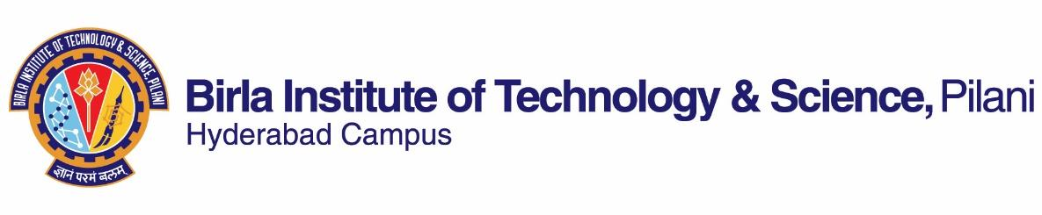

**FIRST SEMESTER 2023-2024**

# Course Handout Part II

Date: 04-08-2023

In addition to Part-I (General Handout for all courses appended to the time table) this portion gives further specific details regarding the course.

Course No. : **BITS F214**

## Course Title : **Science, Technology and Modernity**

Instructor-in-Charge : **Biswanath Dash,** Room No. K 131, HSS

**Scope and Objective of the Course:** The course is aimed at exploring the interrelationship between modern society and science/ technology. Specifically, it seeks to interrogate the relationship in terms of analyzing emergence of modern science in the western world and its implication and contribution to the idea of a modern society. It is largely historical with some amount of philosophical component, provides much scope to explore how science and technology have evolved in world history and how such evolution have shaped human society. It covers to an extent, the impact of such development in India and examines the contemporary debates over the role of science/technology within modernization and globalization.

**Textbooks:**

1. McCllelan III, J.E. and Dorn, H. 2006. *Science and Technology in World History*, Second Edition, Maryland: John Hopkin University Press

**Reference books**

1. Reading material to be uploaded on CMS
2. Bernal, J.D. 1971 *Science in History* Vol. 2. Massachusetts: MIT Press

**Course Plan:**

|  |  |  |  |
| --- | --- | --- | --- |
| **Lecture No.** | **Learning objectives** | **Topics to be covered** | **Chapter in the Text Book** |
| 1-2 | Gain an overall perspective of the course | Course Structure  Science and Technology in Global Context | TB Part I |
| 3-14 | Learn about origin and evolution of Natural Philosophy/Science in different cultures | Greek Natural Philosophy, Arabic Middle Ages  Chinese and  South American Civilization | TB Part I and II  Reading Material |
| 15-25 | Examine emergence of modern science and its role in industrial revolution in the western world | European Renaissance  Scientific and  Industrial Revolution | TB Part III and IV |
| 26-32 | Reflect and analyze evolution of Science/ Technology in India | Vedic period; Gupta era  Moghul period; Colonial India | Reading material |
| 33-40 | Appreciate ‘modernity’ as an idea and its relationship to science and technology | Concepts and debates over Modernity,  Modernity and Globalization | Reading material |

**Evaluation Scheme:**

|  |  |  |  |  |
| --- | --- | --- | --- | --- |
| **Component** | **Duration**  **(Minutes)** | **Weightage (%)** | **Date & Time** | **Nature of Component** |
| Assignment/Quiz | TBA | 20 | TBA | Open Book |
| Mid semester Examination | 90 | 30 | 13/10 - 9.30 - 11.00AM | Closed Book |
| Quiz | TBA | 15 | TBA | Closed Book |
| Comprehensive examination | 180 | 35 | 18/12 FN | Close Book |

**Notices:** Notices will be displayed on CMS.

**Plagiarism:** Cutting and pasting from websites is considered plagiarism. If you are not sure how to write avoiding plagiarism, please ask the instructor. Plagiarism in assignment including from Chat GPT will fetch zero.

**Chamber consultation:** Thursday 12-1 pm

**Make-up Policy:** Make-up for an evaluation component such as Mid Semester and CE will be given only in genuine cases.

**Academic Honesty and Integrity Policy**: Academic honesty and integrity are to be maintained by all the students throughout the semester and no type of academic dishonesty is acceptable.



**Biswanath Dash**

**INSTRUCTOR-IN-CHARGE**